Introduction to Database Project

Fall 2020-21

**Project Name: Art School Management System**

**Table Of Contents**

1. **Introduction**
2. **Case Study**
3. **ER Diagram**
4. **Normalization**
5. **Table Creation with constrains**
6. **Data Insertion**
7. **10 Query**

**Introduction**

An art school is an educational institution with a primary focus on the visual arts, including fine art – especially illustration, painting, photography, sculpture, and graphic design. Art schools can offer elementary, secondary, post-secondary, or undergraduate programs, and can also offer a broad-based range of programs. In art school management is a web base management system where we can see the teacher information easily. On the other hand, who is the principal of this school. Student information can easily find out from here and their parent relationship. Student can see their tuition fees and other fees in their website. And they can know which class they are & subjects also. Teacher also know easily their choosing subjects and class. This is a simple management system for everyone so that they can easily read.

**Case Study:**

Art school management has a strong management for the whole system. The whole system manages by a Principal. The principal as identify as p_id,p_name,phone. Principal hires the teacher as t_name,t_id,Gender,address,Phone. And principal enrolls student which as S_id,S_name,Phone,Gender,Branch,Date_of_birth,Academic_date.Students pays as Tuition_fees_paid,date_of_receipt,ReceiptNo,development_fees_paid,other_fees_paid.Teacher teaches subjects as su_id,Su_name,C_id. And Teacher is assigned to class as c_id,c_name,section.In school students need to identify their parents as pa_name,pa_id,address,phone,relationship_with_address,gender.

**Er Diagram**

**Normalization**

**Takes** (C_id,C_name,Section,S_id,S_name,phone,Gender, Academic_Year,date_of birth,Branch)

1NF:

phone multivalued attribute

2NF:

C_id,C_name,Section

S_id,S_name,phone,Gender, Academic_Year,date_of birth,Branch

CS_id,C_id, S_id

3NF:

C_id,C_name,Section

S_id,S_name,phone,Gender, Academic_Year,date_of birth,Branch

CS_id,C_id, S_id

no transitive dependency

Table:

C_id,C_name,Section

S_id,S_name,phone,Gender, Academic_Year,date_of birth,Branch

CS_id,C_id, S_id

**Is assingned to**(C_id,C_name,Section,T_id,T_name,phone,Gender,Address)

1NF:

phone multivalued attribute

2NF:

C_id,C_name,Section

T_id,T_name,phone,Gender,Address

CT_id,C_id, T_id

3NF:

C_id,C_name,Section

T_id,T_name,phone,Gender,Address

CT_id,C_id, T_id

no transitive dependency

Table:

C_id,C_name,Section

T_id,T_name,phone,Gender,Address

CT_id,C_id, T_id

**Pays** (ReceiptNo,Tution_fees_paid,Date_of_Reciept, development_fees_paid,Other_fees_paid, S_id,S_name,phone,Gender, Academic_Year,date_of birth,Branch)

1NF:

phone multivalued attribute

2NF:

ReceiptNo,Tution_fees_paid,Date_of_Reciept, development_fees_paid,Other_fees_paid

S_id,S_name,phone,Gender, Academic_Year,date_of birth,Branch

RS_id, ReceiptNo, S_id

3NF:

ReceiptNo,Tution_fees_paid,Date_of_Reciept, development_fees_paid,Other_fees_paid

S_id,S_name,phone,Gender, Academic_Year,date_of birth,Branch

RS_id, ReceiptNo, S_id

DR_id,ReceiptNo, Date_of_Reciept

Table:

ReceiptNo,Tution_fees_paid,Date_of_Reciept, development_fees_paid,Other_fees_paid

S_id,S_name,phone,Gender, Academic_Year,date_of birth,Branch

DR_id,ReceiptNo, Date_of_Reciept

**Enrols** (S_id,S_name,phone,Gender, Academic_Year,date_of birth,Branch,P_Id,Phone,P_Name)

1NF:

phone multivalued attribute

2NF:

S_id,S_name,phone,Gender, Academic_Year,date_of birth,Branch,P_Id

P_Id,Phone,P_Name

3NF:

S_id,S_name,phone,Gender, Academic_Year,date_of birth,

Branch,P_Id

P_Id,Phone,P_Name

no transitive dependency

Table:

S_id,S_name,phone,Gender, Academic_Year,date_of birth,Branch

P_Id,Phone,P_Name

**Hires** (P_Id,Phone,P_Name, T_id,T_name,phone,Gender,Address)

1NF:

phone multivalued attribute

2NF:

P_Id,Phone,P_Name

T_id,T_name,phone,Gender,Address, P_Id

3NF:

P_Id,Phone,P_Name

T_id,T_name,phone,Gender,Address,P_Id

no transitive dependency

Table:

P_Id,Phone,P_Name

T_id,T_name,phone,Gender,Address,P_Id

**Teaches**(T_id,T_name,phone,Gender,Address,C_ID,Su_Name,Su_ID)

1NF:

phone multivalued attribute

2NF:

Su_ID,Su_Name, C_ID, T_id

T_id,T_name,phone,Gender,Address

3NF:

Su_ID,Su_Name, C_ID, T_id

T_id,T_name,phone,Gender,Address

no transitive dependency

Table:

Su_ID,Su_Name, C_ID, T_id

T_id,T_name,phone,Gender,Address

**Adds**(Su_ID,Su_Name, C_ID, P_Id,Phone,P_Name)

1NF:

phone multivalued attribute

2NF:

Su_ID,Su_Name, C_ID, P_Id

P_Id,Phone,P_Name

3NF:

Su_ID,Su_Name, C_ID, P_Id

P_Id,Phone,P_Name

no transitive dependency

Table:

Su_ID,Su_Name, C_ID, P_Id

P_Id,Phone,P_Name

**Have**(S_id,S_name,phone,Gender, Academic_Year,date_of birth,

Branch,Pa ID,pa_Name,Address,phone,Relationship_with_student)

1NF:

phone multivalued attribute

2NF:

S_id,S_name,phone,Gender, Academic_Year,date_of birth,Branch, Pa ID

Pa ID,pa_Name,Address,phone,Relationship_with_student

3NF:

S_id,S_name,phone,Gender, Academic_Year,date_of birth,Branch, Pa ID

Pa ID,pa_Name,Address,phone,Relationship_with_student

no transitive dependency

Table:

S_id,S_name,phone,Gender, Academic_Year,date_of birth,Branch, Pa ID

Pa ID,pa_Name,Address,phone,Relationship_with_student

**Total Table:**

~~C_id,C_name,Section~~

~~S_id,S_name,phone,Gender, Academic_Year,date_of birth,Branch~~

CS_id,C_id, S_id

C_id,C_name,Section

~~T_id,T_name,phone,Gender,Address~~

CT_id,C_id, T_id

ReceiptNo,Tution_fees_paid,Date_of_Reciept, development_fees_paid,Other_fees_paid

~~S_id,S_name,phone,Gender, Academic_Year,date_of birth,Branch~~

DR_id,ReceiptNo, Date_of_Reciept

~~S_id,S_name,phone,Gender, Academic_Year,date_of birth,Branch~~

~~P_Id,Phone,P_Name~~

~~P_Id,Phone,P_Name~~

T_id,T_name,phone,Gender,Address,P_Id

~~Su_ID,Su_Name, C_ID, T_id~~

~~T_id,T_name,phone,Gender,Address~~

Su_ID,Su_Name, C_ID, T_id

~~T_id,T_name,phone,Gender,Address~~

Su_ID,Su_Name, C_ID, P_Id

P_Id,Phone,P_Name

S_id,S_name,phone,Gender, Academic_Year,date_of birth,Branch, Pa ID

Pa ID,pa_Name,Address,phone,Relationship_with_student

**Final Table:**

1. CS_id,C_id, S_id

2. C_id,C_name,Section

3. CT_id,C_id, T_id

4. ReceiptNo,Tution_fees_paid,Date_of_Reciept, development_fees_paid,Other_fees_paid

5. DR_id,ReceiptNo, Date_of_Reciept

6. T_id,T_name,phone,Gender,Address,P_Id

7. Su_ID,Su_Name, C_ID, T_id

8. Su_ID,Su_Name, C_ID, P_Id

9. P_Id,Phone,P_Name

10. S_id,S_name,phone,Gender, Academic_Year,date_of _birth, Pa_ID

11. Pa ID,pa_Name,Address,phone,Relationship_with_student

TABLE CREATION WITH CONSTRAINS:

1.CS TABLE:

create table cs

(

cs_id number(10) not null,

c_id number(10) primary key,

s_id number(10) unique

)

desc cs;

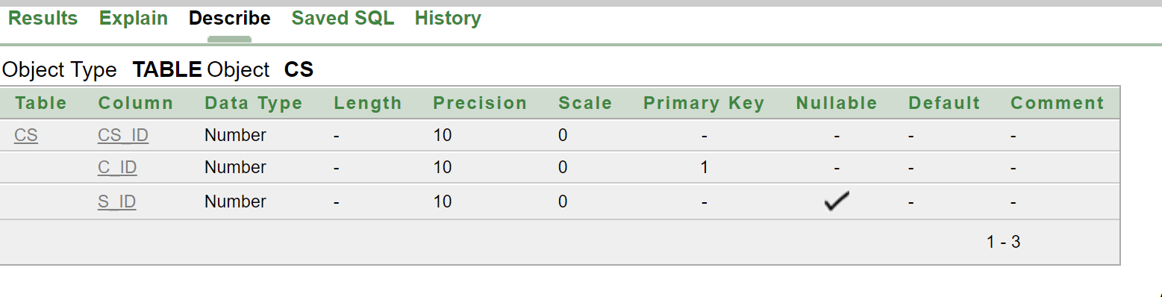

2.CLASS TABLE:

create table class

(

c_id number(10) constraint cs_c_id_fk references cs (c_id),

c_name varchar2(10),

section varchar2(2)

)

desc class; 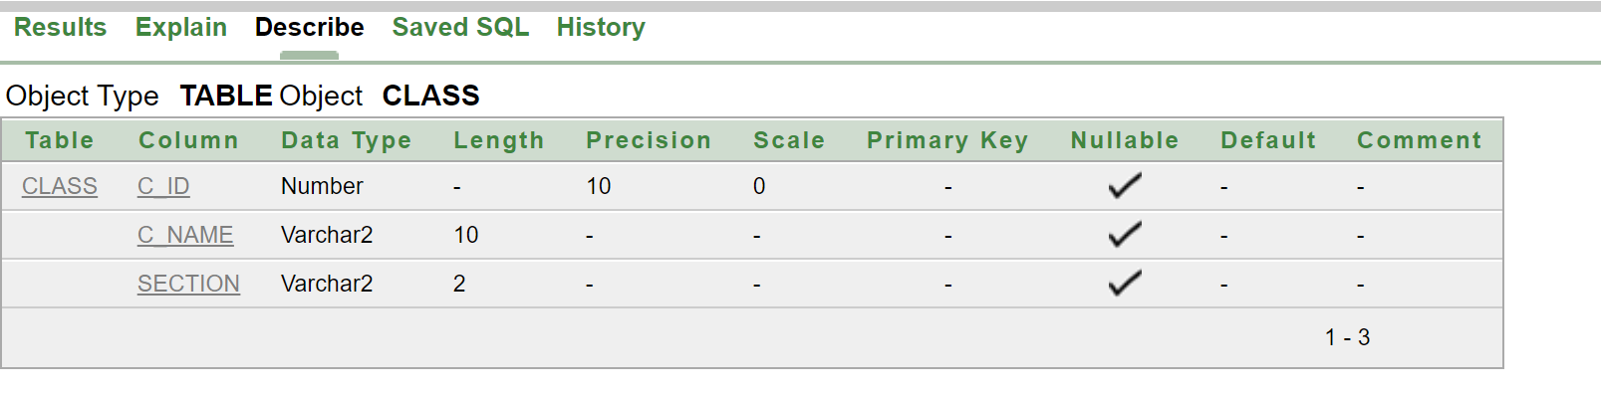

**3.CT TABLE:**

create table ct

(

c_id number(10) primary key,

FOREIGN KEY (c_id) REFERENCES cs(c_id) ON DELETE CASCADE,

CT_id number(10) ,

T_id number(10) not null

)

desc ct;

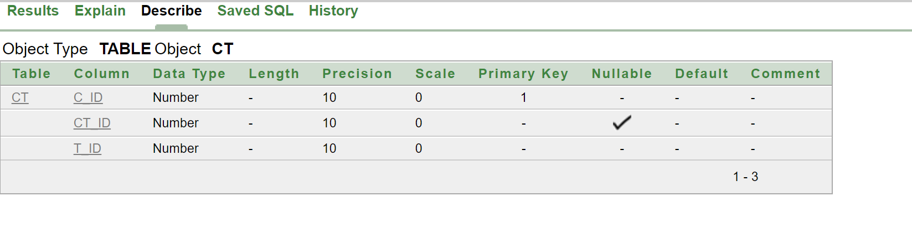

**4.PAYS TABLE:**

create table pays

(

ReceiptNo Number(10) primary key,

Tution_fees number(20) not null,

Date_of_reciept date,

Development_fees_paid number(10)not null,

Other_fees_paid number(10)

)

desc pays;

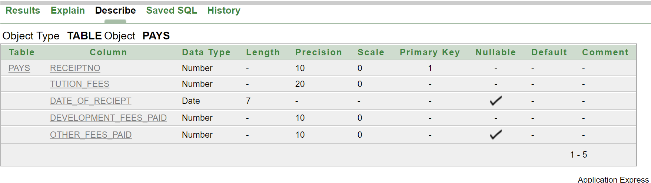

**5.DR TABLE:**

create table dr

(

Dr_id number(10) primary key,

ReceiptNo number(10) constraint pays_ReceiptNo_fk references pays (ReceiptNo),

Date_of_reciept date

)

desc dr;

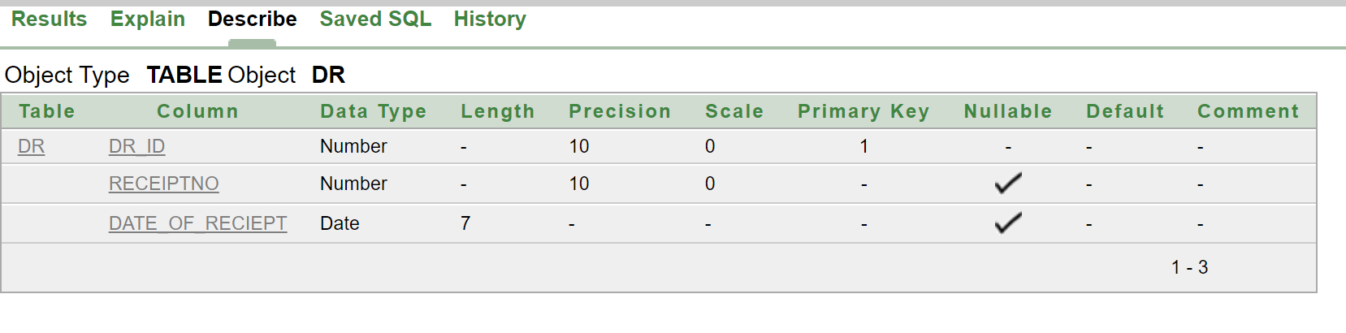

**6.TEACHER TABLE:**

create table teacher

(

T_id number(10) primary key,

T_name varchar(10),

Phone number(15) unique,

Gender varchar(6),

Address varchar2(50),

P_id int

)

desc teacher;

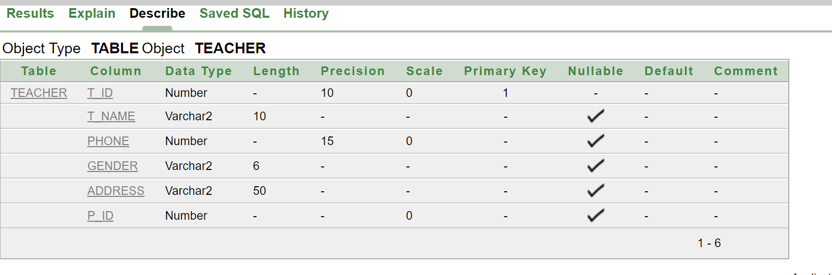

**7.SU TABLE:**

create table Su

(

Su_id number(10) primary key,

Su_name varchar(12),

C_id number(10),

FOREIGN KEY (c_id) REFERENCES cs(c_id) ON DELETE CASCADE,

T_id number (10) constraint teacher_T_id_fk references teacher(T_id)

)

desc Su;

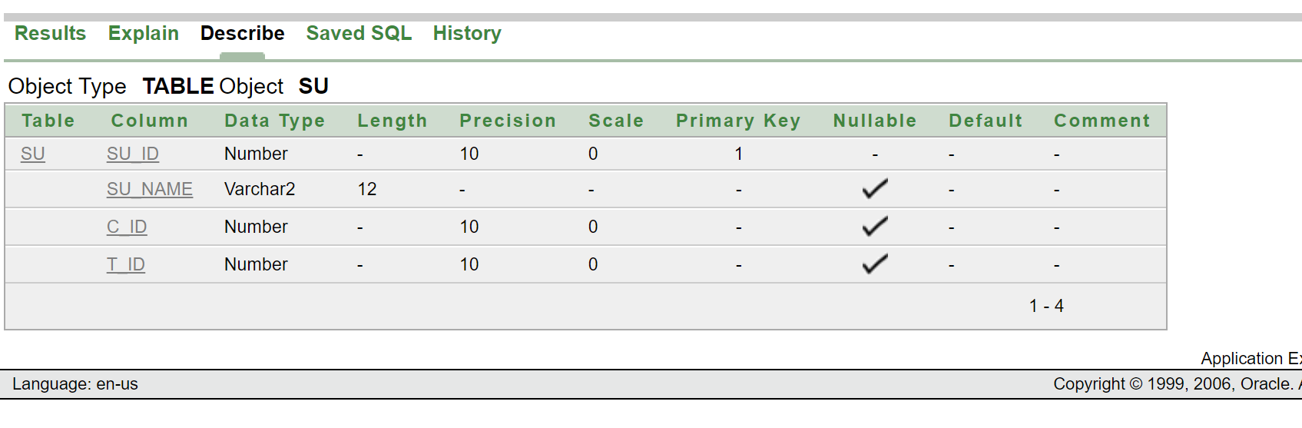

**8.SP TABLE:**

create table SP

(

Su_id number(10) primary key,

FOREIGN KEY (Su_id) REFERENCES Su(Su_id) ON DELETE CASCADE,

Su_name varchar2(12),

C_id number(10),

P_id int

)

desc Sp;

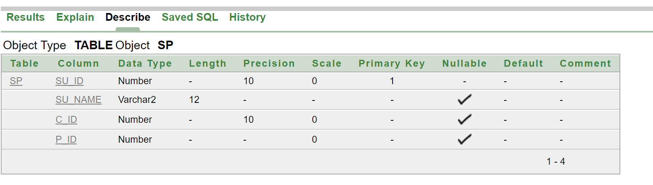

**9.PRINCIPAL TABLE:**

create table Principal

(

P_id number(10),

Phone number (15),

P_name varchar2(10)

)

desc Principal;

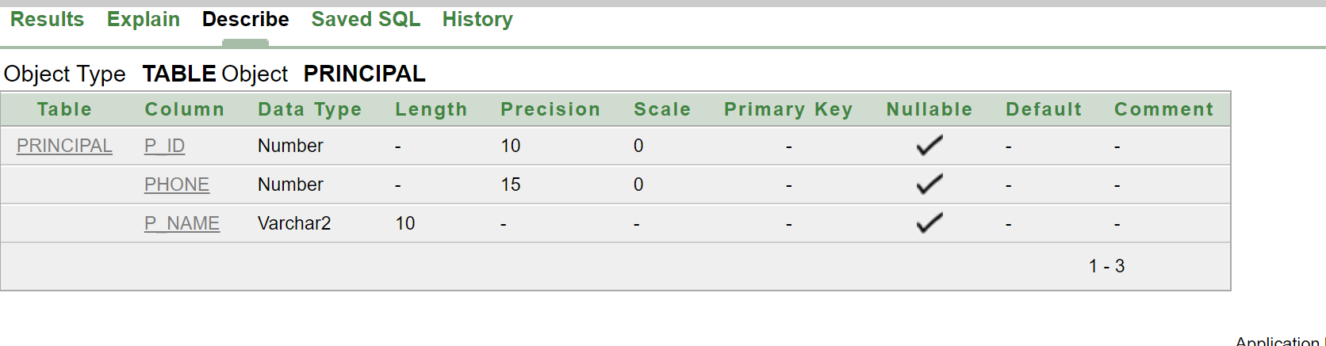

**10.STUDENT TABLE:**

create table student

(

S_id number(10) unqiue,

S_name varchar2(15),

Phone number (15),

Gender varchar2(6),

Academic_Year date,

Date_of_birth date,

Pa_id number(10)

)

desc student;

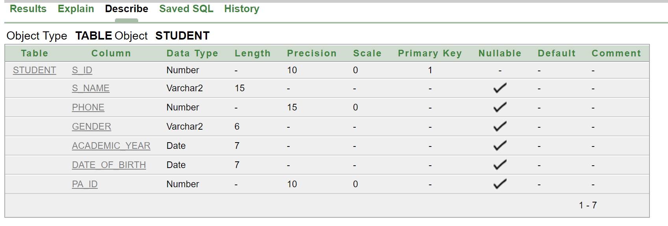

**11.PARENTS TABLE:**

create table parents

(

Pa_id number(10) primary key,

Pa_name varchar2(15),

Address varcher2(15),

Phone varchar2(15),

Relationship_with_student varchar2(15)

)

desc parents;

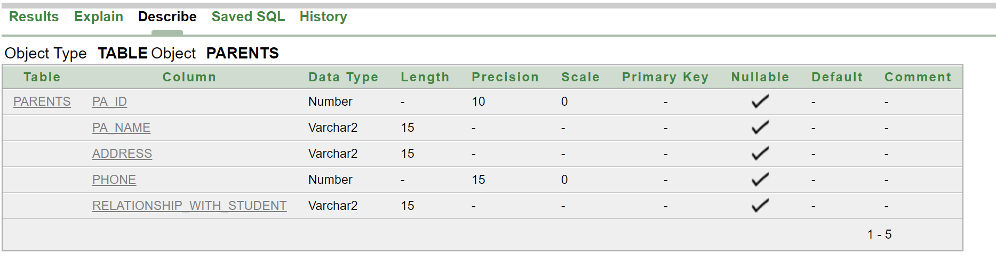

DATA INSERTATION

**Class**

INSERT INTO class(C_id,C_name,Section)

VALUES(2001,'ASIF HASAN','A')

INSERT INTO class(C_id,C_name,Section)

VALUES(2002,'BADHON Haq','A')

INSERT INTO class(C_id,C_name,Section)

VALUES(2003,'SADMAN Ali','A')

INSERT INTO class(C_id,C_name,Section)

VALUES(2004,'MAHMUDUL','A')

INSERT INTO class(C_id,C_name,Section)

VALUES(2005,'IMTIAZ','C')

INSERT INTO class(C_id,C_name,Section)

VALUES(2006,'Anik Islam','B')

INSERT INTO class(C_id,C_name,Section)

VALUES(2007,'Jafor Ali','B')

INSERT INTO class(C_id,C_name,Section)

VALUES(2008,'Himel Khan','B')

INSERT INTO class(C_id,C_name,Section)

VALUES(2009,'Sakib','C')

INSERT INTO class(C_id,C_name,Section)

VALUES(2010,'Sowrov','C')

select * from class

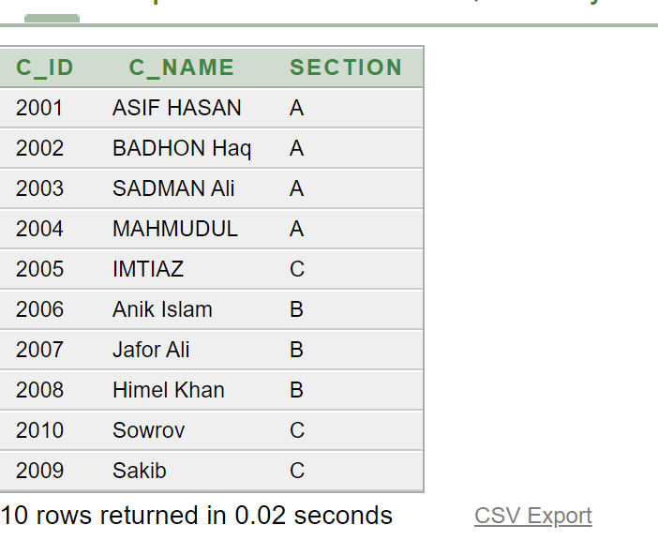

**CS**

INSERT INTO cs(CS_id,C_id, S_id)

VALUES(1001,2001,3001);

INSERT INTO cs(CS_id,C_id, S_id)

VALUES(1002,2002,3002);

INSERT INTO cs(CS_id,C_id, S_id)

VALUES(1003,2003,3003);

INSERT INTO cs(CS_id,C_id, S_id)

VALUES(1004,2004,3004);

INSERT INTO cs(CS_id,C_id, S_id)

VALUES(1005,2005,3005);

INSERT INTO cs(CS_id,C_id, S_id)

VALUES(1006,2006,3006);

INSERT INTO cs(CS_id,C_id, S_id)

VALUES(1007,2007,3007);

INSERT INTO cs(CS_id,C_id, S_id)

VALUES(1008,2008,3008);

INSERT INTO cs(CS_id,C_id, S_id)

VALUES(1009,2009,3009);

INSERT INTO cs(CS_id,C_id, S_id)

VALUES(1010,2010,3010);

select * from cs

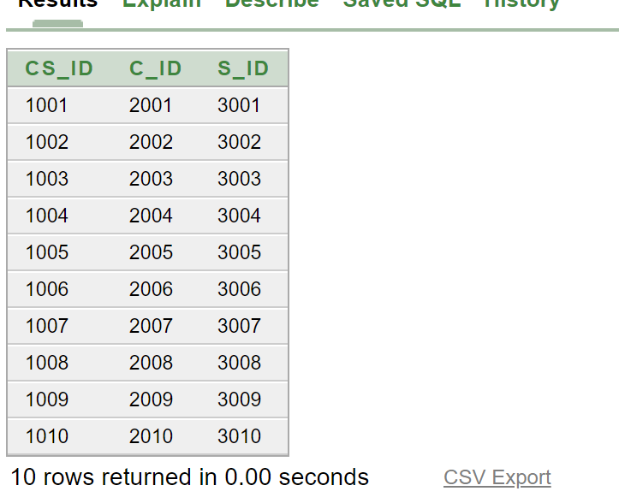

**CT**

INSERT INTO ct(CT_id,C_id, T_id)

VALUES(5001,2001,4301)

INSERT INTO ct(CT_id,C_id, T_id)

VALUES(5002,2002,4302)

INSERT INTO ct(CT_id,C_id, T_id)

VALUES(5003,2003,4303)

INSERT INTO ct(CT_id,C_id, T_id)

VALUES(5004,2004,4304)

INSERT INTO ct(CT_id,C_id, T_id)

VALUES(5005,2005,4305)

INSERT INTO ct(CT_id,C_id, T_id)

VALUES(5006,2006,4306)

INSERT INTO ct(CT_id,C_id, T_id)

VALUES(5007,2007,4307)

INSERT INTO ct(CT_id,C_id, T_id)

VALUES(5008,2008,4308)

INSERT INTO ct(CT_id,C_id, T_id)

VALUES(5009,2009,4309)

INSERT INTO ct(CT_id,C_id, T_id)

VALUES(5010,2010,4310)

select * from ct

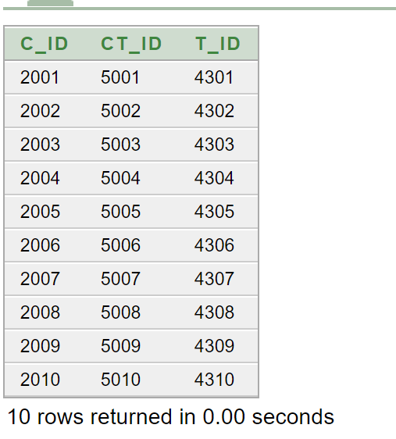

**Pays**

INSERT INTO pays(ReceiptNo,Tution_fees,Date_of_Reciept, development_fees_paid,Other_fees_paid)

VALUES(7631,1200,'26-August-2020',500,100);

INSERT INTO pays(ReceiptNo,Tution_fees,Date_of_Reciept, development_fees_paid,Other_fees_paid)

VALUES(7632,1200,'21-August-2020',500,100);

INSERT INTO pays(ReceiptNo,Tution_fees,Date_of_Reciept, development_fees_paid,Other_fees_paid)

VALUES(7633,1100,'27-August-2020',500,100);

INSERT INTO pays(ReceiptNo,Tution_fees,Date_of_Reciept, development_fees_paid,Other_fees_paid)

VALUES(7634,1000,'21-August-2020',500,100);

INSERT INTO pays(ReceiptNo,Tution_fees,Date_of_Reciept, development_fees_paid,Other_fees_paid)

VALUES(7635,1100,'29-August-2020',500,100);

INSERT INTO pays(ReceiptNo,Tution_fees,Date_of_Reciept, development_fees_paid,Other_fees_paid)

VALUES(7636,1000,'20-August-2020',500,100);

INSERT INTO pays(ReceiptNo,Tution_fees,Date_of_Reciept, development_fees_paid,Other_fees_paid)

VALUES(7637,1200,'12-August-2020',500,100);

INSERT INTO pays(ReceiptNo,Tution_fees,Date_of_Reciept, development_fees_paid,Other_fees_paid)

VALUES(7638,1200,'16-August-2020',500,100);

INSERT INTO pays(ReceiptNo,Tution_fees,Date_of_Reciept, development_fees_paid,Other_fees_paid)

VALUES(7639,700,'18-August-2020',500,100);

INSERT INTO pays(ReceiptNo,Tution_fees,Date_of_Reciept, development_fees_paid,Other_fees_paid)

VALUES(7640,800,'13-August-2020',500,100);

Select * from pays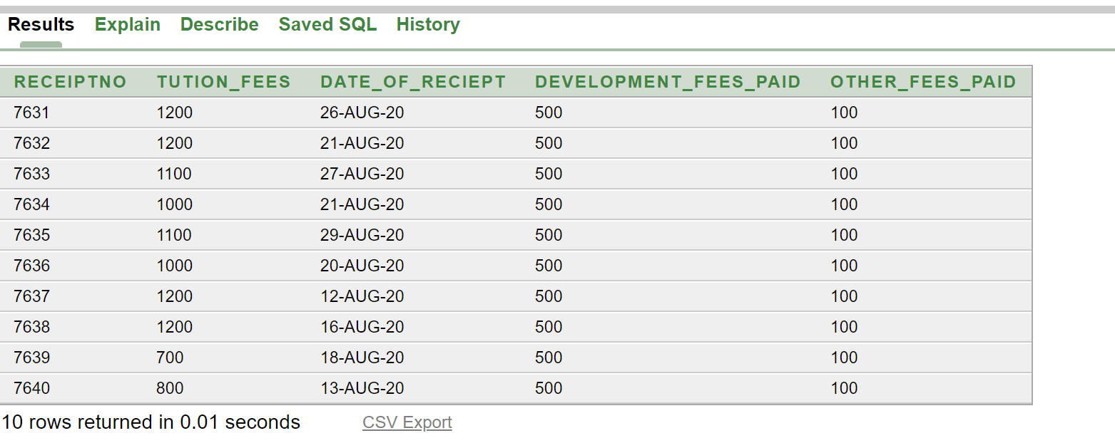

**Dr**

INSERT INTO dr(DR_id,ReceiptNo, Date_of_Reciept)

VALUES(6681,7631,'26-August-2020');

INSERT INTO dr(DR_id,ReceiptNo, Date_of_Reciept)

VALUES(6682,7632,'21-August-2020');

INSERT INTO dr(DR_id,ReceiptNo, Date_of_Reciept)

VALUES(6683,7633,'27-August-2020');

INSERT INTO dr(DR_id,ReceiptNo, Date_of_Reciept)

VALUES(6684,7634,'21-August-2020');

INSERT INTO dr(DR_id,ReceiptNo, Date_of_Reciept)

VALUES(6685,7635,'29-August-2020');

INSERT INTO dr(DR_id,ReceiptNo, Date_of_Reciept)

VALUES(6686,7636,'20-August-2020');

INSERT INTO dr(DR_id,ReceiptNo, Date_of_Reciept)

VALUES(6687,7637,'12-August-2020');

INSERT INTO dr(DR_id,ReceiptNo, Date_of_Reciept)

VALUES(6688,7638,'16-August-2020');

INSERT INTO dr(DR_id,ReceiptNo, Date_of_Reciept)

VALUES(6689,7639,'18-August-2020');

INSERT INTO dr(DR_id,ReceiptNo, Date_of_Reciept)

VALUES(6690,7640,'13-August-2020');

Select * from dr

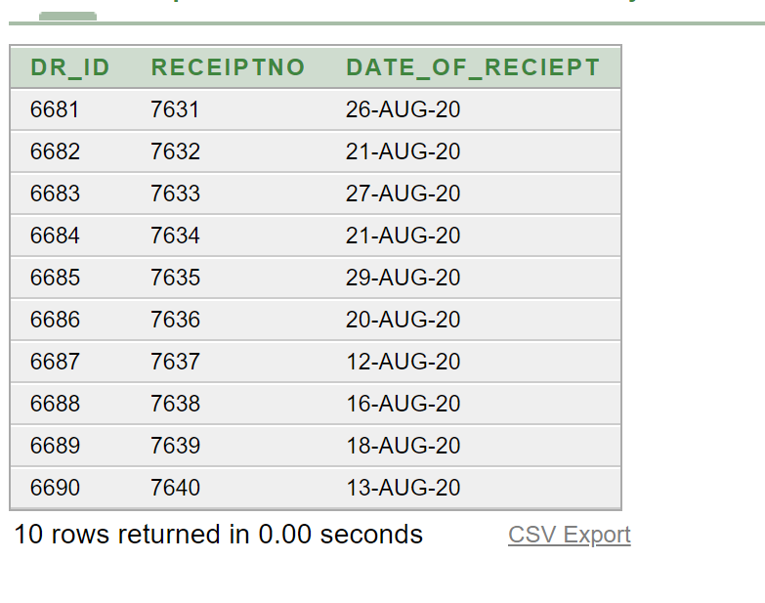

**Teacher**

INSERT INTO teacher(T_id,T_name,phone,Gender,Address,P_Id)

VALUES(4301,'SRABON ','01419855236','MALE', 'MIRPUR',105);

INSERT INTO teacher(T_id,T_name,phone,Gender,Address,P_Id)

VALUES(4302,'JOUNAL ','01919855236','MALE', 'MIRPUR',102);

INSERT INTO teacher(T_id,T_name,phone,Gender,Address,P_Id)

VALUES(4303,'KARIM ','01719555236','MALE', 'MIRPUR',150);

INSERT INTO teacher(T_id,T_name,phone,Gender,Address,P_Id)

VALUES(4304,'RAHIM ','01819555236','MALE','UTTARA',140);

INSERT INTO teacher(T_id,T_name,phone,Gender,Address,P_Id)

VALUES(4305,'HAMIM ','01559555236','MALE','COMILLA',153);

INSERT INTO teacher(T_id,T_name,phone,Gender,Address,P_Id)

VALUES(4306,'KONA ','01711988236','FEMALE', 'SYLET',162);

INSERT INTO teacher(T_id,T_name,phone,Gender,Address,P_Id)

VALUES(4307,'ASIM ','01919565236','MALE', 'KHULNA',202);

INSERT INTO teacher(T_id,T_name,phone,Gender,Address,P_Id)

VALUES(4308,'REHANA ','017118555236','FEMALE', 'MIRPUR',165);

INSERT INTO teacher(T_id,T_name,phone,Gender,Address,P_Id)

VALUES(4309,'ARSHI’,'018519555236','FEMALE', 'GULSAN',222);

INSERT INTO teacher(T_id,T_name,phone,Gender,Address,P_Id)

VALUES(4310,'ALEX','01919555236','FEMALE', 'MIRPUR',213);

Select * from teacher

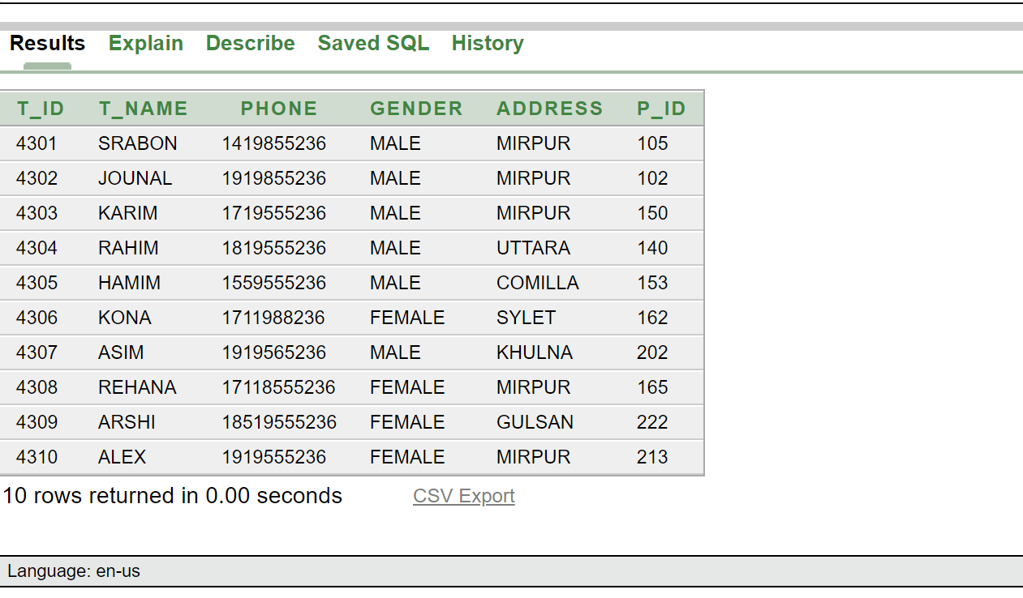

**Su**

INSERT INTO Su(Su_ID,Su_Name, C_ID, T_id)   
VALUES(50001,'Sculpture',2001,4301);

INSERT INTO Su(Su_ID,Su_Name, C_ID, T_id)   
VALUES(50002,'Printmaking',2002,4302);

INSERT INTO Su(Su_ID,Su_Name, C_ID, T_id)   
VALUES(50003,'Art design',2003,4303);

INSERT INTO Su(Su_ID,Su_Name, C_ID, T_id)   
VALUES(50004,'Drawing',2004,4304);

INSERT INTO Su(Su_ID,Su_Name, C_ID, T_id)   
VALUES(50005,'Studio arts',2005,4305);

INSERT INTO Su(Su_ID,Su_Name, C_ID, T_id)   
VALUES(50006,'Architecture',2006,4306);

INSERT INTO Su(Su_ID,Su_Name, C_ID, T_id)   
VALUES(50007,'Digitalmedia',2007,4307);

INSERT INTO Su(Su_ID,Su_Name, C_ID, T_id)   
VALUES(50008,'Photography',2008,4308);

INSERT INTO Su(Su_ID,Su_Name, C_ID, T_id)   
VALUES(50009,'Animation',2009,4309);

INSERT INTO Su(Su_ID,Su_Name, C_ID, T_id)   
VALUES(50010,'Graphic Des.',2010,4310);

select * from Su

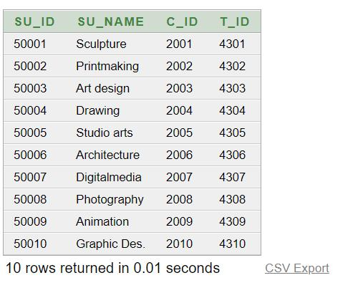

**Sp**

INSERT INTO SP(Su_ID,Su_Name, C_ID, P_Id)

VALUES(50001,'Sculpture',2001,105);

INSERT INTO SP(Su_ID,Su_Name, C_ID, P_Id)

VALUES(50002,'Printmaking',2002,105);

INSERT INTO SP(Su_ID,Su_Name, C_ID, P_Id)

VALUES(50003,'Art design',2003,105);

INSERT INTO SP(Su_ID,Su_Name, C_ID, P_Id)

VALUES(50004,'Drawing ',2004,105);

INSERT INTO SP(Su_ID,Su_Name, C_ID, P_Id)

VALUES(50005,'Studio arts',2005,105);

INSERT INTO SP(Su_ID,Su_Name, C_ID, P_Id)

VALUES(50006,'Architecture',2006,105);

INSERT INTO SP(Su_ID,Su_Name, C_ID, P_Id)

VALUES(50007,'Digitalmedia',2007,105);

INSERT INTO SP(Su_ID,Su_Name, C_ID, P_Id)

VALUES(50008,'Photography',2008,105);

INSERT INTO SP(Su_ID,Su_Name, C_ID, P_Id)

VALUES(50009,'Animation',2009,105);

INSERT INTO SP(Su_ID,Su_Name, C_ID, P_Id)

VALUES(50010,'Graphic Des.',2010,105);

select * from Sp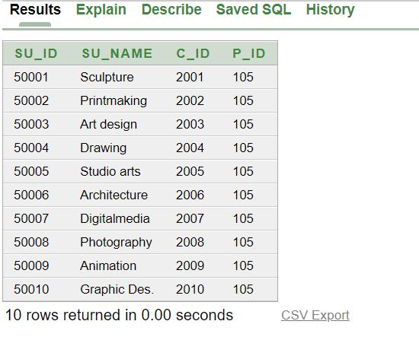

**Principal**

INSERT INTO Principal(P_Id,Phone,P_Name)

VALUES(105,'01971555236','HASAN ');

Select * from principal

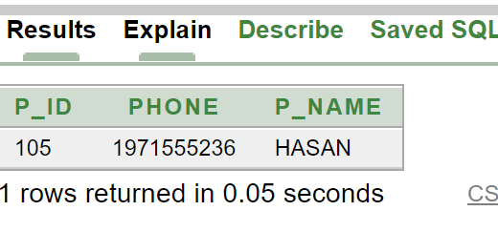

**Student**

INSERT INTO student(S_id,S_name,phone,Gender, Academic_Year,date_of birth,Branch, Pa ID)

VALUES(3001,'JAVED ALI','01511639433','MALE','13-August-2018','3-August-2002','MIRPUR',10001);

INSERT INTO student(S_id,S_name,phone,Gender, Academic_Year,date_of birth,Branch, Pa ID)

VALUES(3002,'ROJA KHAN','01811639433','FEMALE','13-August-2018','3-JANUARY-2002','MIRPUR',10002);

INSERT INTO student(S_id,S_name,phone,Gender, Academic_Year,date_of birth,Branch, Pa ID)

VALUES(3003,'SAFAEAT KHAN','01911639433','MALE','13-August-2016','26-JANUARY-2002','MIRPUR',10003);

INSERT INTO student(S_id,S_name,phone,Gender, Academic_Year,date_of birth,Branch, Pa ID)

VALUES(3004,'ABRAR AHMED'','01955639433','MALE','13-August-2016','2-JANUARY-2002','MIRPUR',10004);

INSERT INTO student(S_id,S_name,phone,Gender, Academic_Year,date_of_birth, Pa_ID)

VALUES(3005,'ANNAYA KHAN','01711639433','FEMALE','13-August-2016','26-SEPTEMBER-2002','GULSAN',10005);

INSERT INTO student(S_id,S_name,phone,Gender, Academic_Year,date_of_birth, Pa_ID)

VALUES(3006,'ANNAYA AKTER','01798639433','FEMALE','13-August-2018','26-OCTOBER-2002','GULSAN',10006);

INSERT INTO student(S_id,S_name,phone,Gender, Academic_Year,date_of_birth, Pa_ID)

VALUES(3007,'ABIR HOSSEN','0159639455','MALE',13-August-2018','20-OCTOBER-2004','MIRPUR',10007);

INSERT INTO student(S_id,S_name,phone,Gender, Academic_Year,date_of_birth, Pa_ID)

VALUES(3008,'ASIF HOSSEN','0159539455','MALE',13-August-2018','2-OCTOBER-2002','MIRPUR',10008);

INSERT INTO student(S_id,S_name,phone,Gender, Academic_Year,date_of_birth,Pa_ID)

VALUES(3009,'SIAM KHAN','0189539455','MALE',13-August-2018','2-MAY-2002','MIRPUR',10009);

INSERT INTO student(S_id,S_name,phone,Gender, Academic_Year,date_of_birth, , Pa_ID)

VALUES(3010,'ALI HOSSEN','01595377555','MALE',13-August-2018','2-JUNE-2002','MIRPUR',10010);

Select * from student

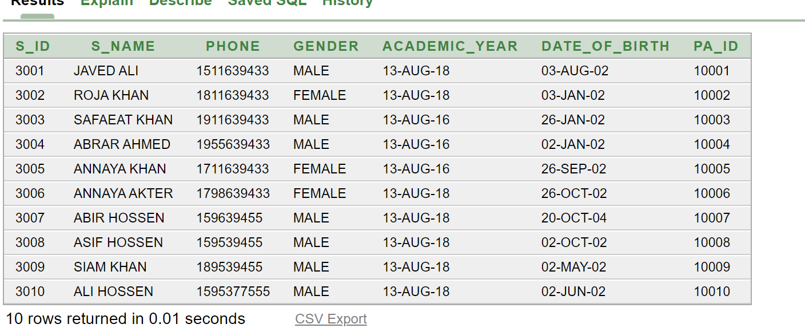

**Parents**

INSERT INTO parents(Pa ID,pa_Name,Address,phone,Relationship_with_student )

VALUES(80001,'AFZAL HOSSEN','MIRPUR','01813048025','FATHER');

INSERT INTO parents(Pa ID,pa_Name,Address,phone,Relationship_with_student )

VALUES(80002,'ABUL HOSSEN','MIRPUR','01913048025','FATHER');

INSERT INTO parents(Pa ID,pa_Name,Address,phone,Relationship_with_student )

VALUES(80003,'KONIKA HOSSEN','MIRPUR','01814048025','MOTHER');

INSERT INTO parents(Pa ID,pa_Name,Address,phone,Relationship_with_student )

VALUES(80004,'ALIF HOSSEN','GULSAN','01713048025','FATHER');

INSERT INTO parents(Pa ID,pa_Name,Address,phone,Relationship_with_student )

VALUES(80005,'RABEYA HOSSEN','MIRPUR','01813058025','MOTHER');

INSERT INTO parents(Pa ID,pa_Name,Address,phone,Relationship_with_student )

VALUES(80006,'AKRAM HOSSEN','MIRPUR','01813048022','FATHER');

INSERT INTO parents(Pa ID,pa_Name,Address,phone,Relationship_with_student )

VALUES(80007,'AFZAL KHAN','GULSAN','01813058025','FATHER');

INSERT INTO parents(Pa ID,pa_Name,Address,phone,Relationship_with_student )

VALUES(80008,'REKSONA BEGUM','MIRPUR','01813048027','MOTHER');

INSERT INTO parents(Pa ID,pa_Name,Address,phone,Relationship_with_student )

VALUES(80009,'SALAUDDIN AHMED','MIRPUR','01552248025','FATHER');

INSERT INTO parents(Pa ID,pa_Name,Address,phone,Relationship_with_student )

VALUES(80010,'FOYSAL HOSSEN','MIRPUR','01813458025','FATHER');

Select * from parents

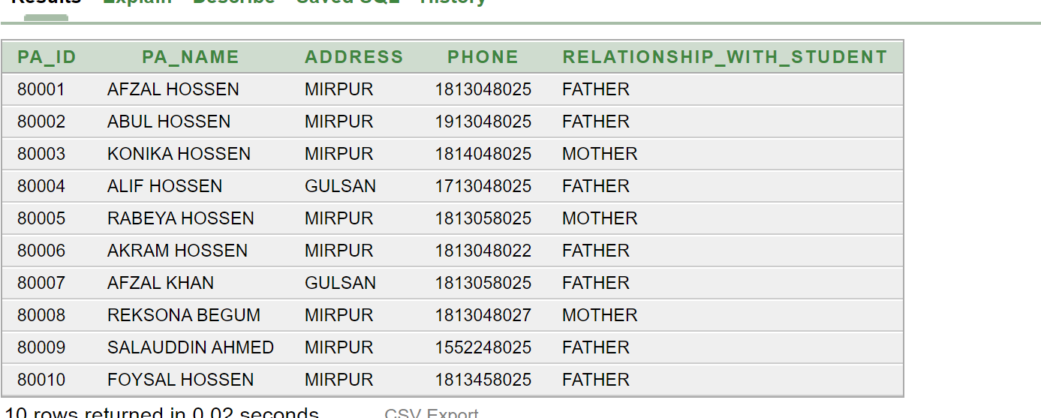

**10 Query:**

**Single Row Sub query**

Select t_name from teacher where address=(select address from teacher where t_id=4301) and gender =(Select gender from teacher where t_id=4304)

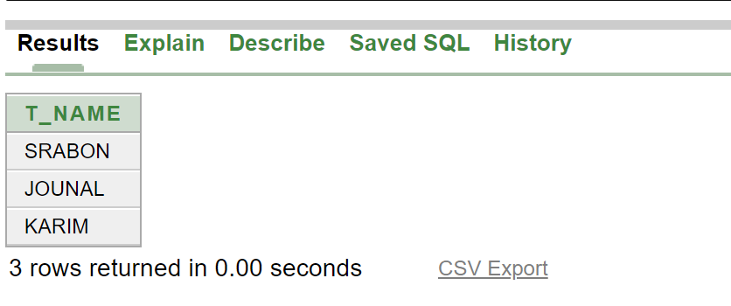

**Sub query**

1. select receiptno,date_of_reciept from pays where tution_fees=(select max (tution_fees)from pays)

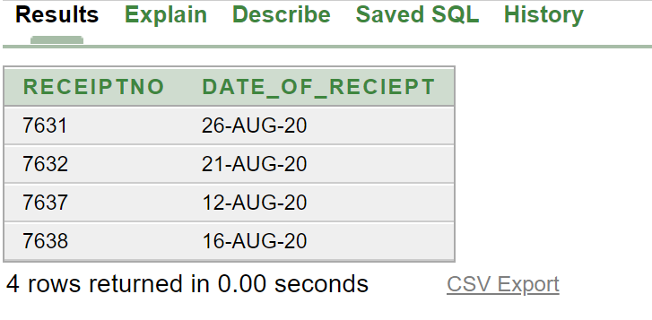

1. select date_of_reciept from pays where tution_fees>(select tution_fees from pays where receiptno=7640)

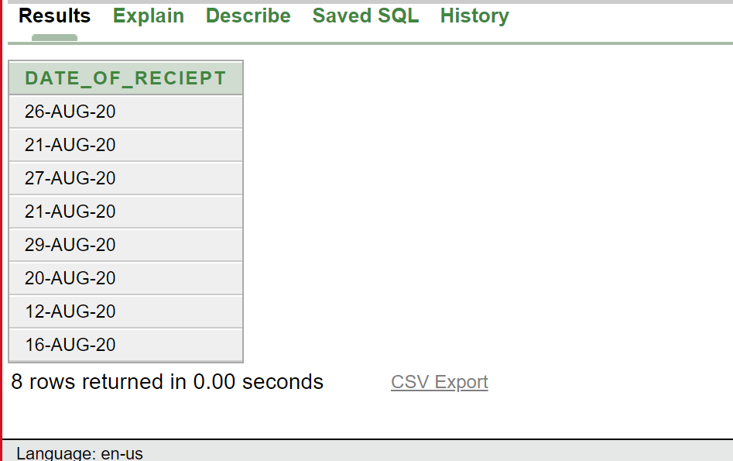

1. select Su_name,su_id from su where T_id in(select T_id from teacher)

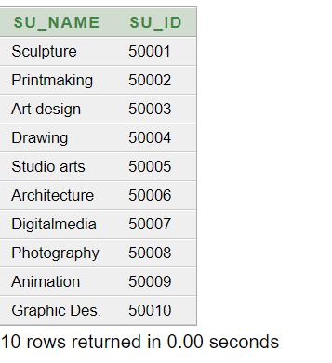

1. select receiptNo from pays where tution_fees in (select max(tution_fees)from pays where tution_fees <>(select max(tution_fees)from pays))

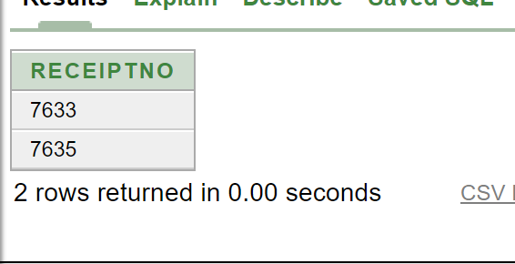

**Group function**

1.select section,count(*) from class group by section

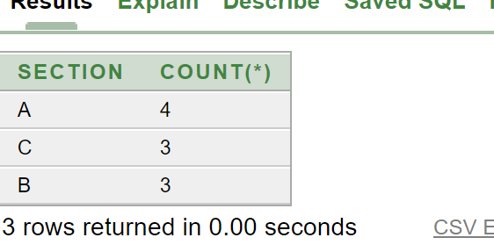

2. select date_of_reciept from pays where tution_fees in(select max(tution_fees)from pays group by receiptno)

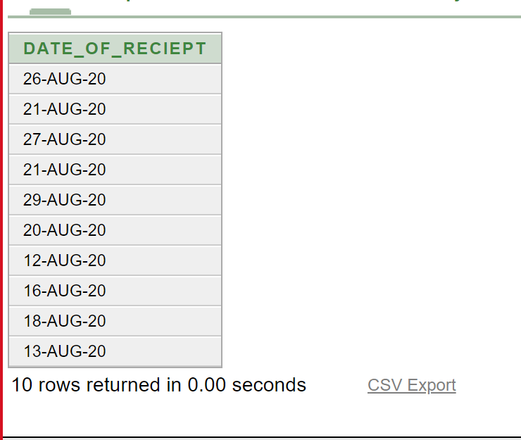

**Joining**

1. select su.Su_id, Su.Su_name,su.c_id,p.phone,p.p_name from SP su, principal p where su.P_Id = p.P_Id

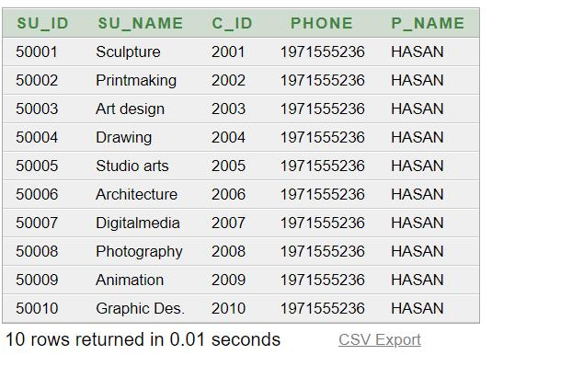2. Select T.T_name,T.phone,s.Su_name from Teacher T, Su s where T.T_id=S.T_id

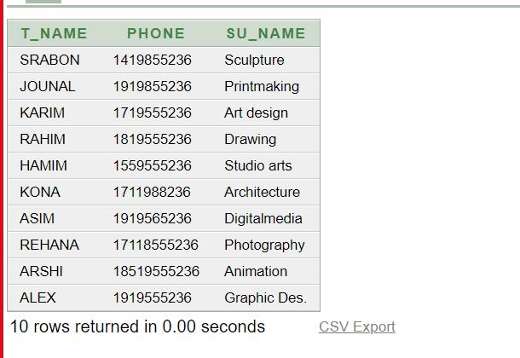

3. Select T.T_name,T.phone,s.Su_name,C.C_name,C.Section from Teacher T, Su s,Class C where T.T_id=S.T_id and C.C_id=S.C_id

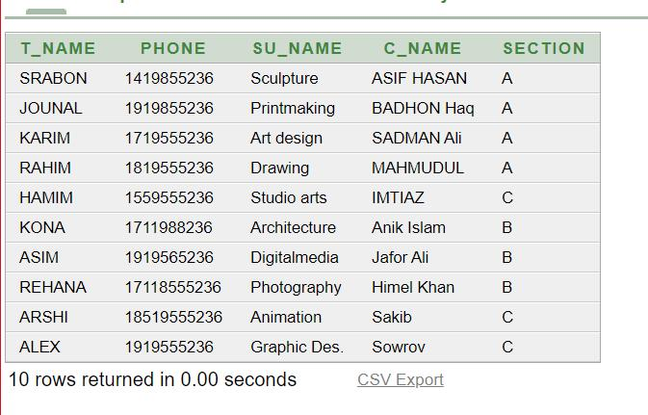

**View**

create or replace view SPP

as

select su.Su_id, Su.Su_name,su.c_id,p.phone,p.p_name from SP su, principal p where su.P_Id = p.P_Id

Select * from SPP

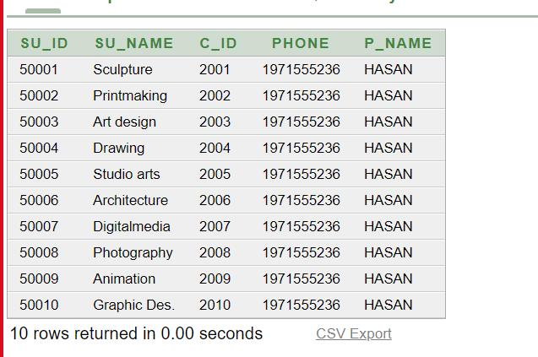

**THE END**